****EatzAI****

**(A modern solution for effortless ordering and dining.)**

**Design Document**

(**Restaurant Chatbot Project**)

Version 1.0



Group Id: F24PROJECT7B8AC

Supervisor Name : Abdullah Qamar    (abdullah.qamar@vu.edu.pk)

**Revision History**

|  |  |  |  |
| --- | --- | --- | --- |
| **Date (dd/mm/yyyy)** | **Version** | **Description** | **Author** |
| 27/02/2025 | 1.0 | The project focuses on developing a restaurant-specific chatbot using Google Dialogflow, leveraging Natural Language Processing (NLP) to automate essential customer interactions. The chatbot will streamline tasks such as table reservations, order placement, menu navigation, and customer support, enhancing the overall dining experience. By offering a conversational interface, it aims to improve operational efficiency, reduce human intervention, and provide a seamless, user-friendly solution for restaurant customers. | Bc200417404 |
|  |  |  |  |
|  |  |  |  |
|  |  |  |  |

**Table of Contents**

1. Introduction of Design Document
2. Entity Relationship Diagram (ERD)
3. Sequence Diagrams
4. Architecture Design Diagram
5. Class Diagram
6. Database Design
7. Interface Design
8. Test Cases

1. Introduction of Design Document

**Purpose of the Document**

This design document outlines the architectural and design specifications for the development of an NLP-based restaurant chatbot using Google Dialogflow. It provides a comprehensive blueprint for system developers, designers, and stakeholders, ensuring a unified understanding of the system's functionalities and its technical implementation. By presenting detailed designs for the chatbot’s components, this document facilitates efficient development, reduces risks, and supports future scalability and maintainability.

**Objectives of the Design Phase**

The primary objective of the design phase is to translate the functional and non-functional requirements into actionable, structured designs. This ensures:

1. **Clarity**: Providing a clear understanding of system workflows and technical components.
2. **Consistency**: Aligning the development team’s efforts with the project’s goals and scope.
3. **Risk Mitigation**: Identifying and addressing potential design challenges early in the development lifecycle.
4. **Scalability**: Designing a system that can adapt to future requirements and handle increased loads as needed.

**Benefits of the Design Document**

* **Streamlined Development**: Acts as a reference point for developers, minimizing ambiguities during implementation.
* **Enhanced Communication**: Provides a shared understanding of the system’s structure for all stakeholders.
* **Facilitates Testing and Validation**: Lays the groundwork for developing comprehensive test cases and validating the system’s functionality.
* **Future Reference**: Serves as documentation for system upgrades, maintenance, and scaling.

**Key Components Covered in the Design Document**

This document includes the following sections:

1. **Entity Relationship Diagram (ERD)**: Illustrates the data model and relationships among entities in the system.
2. **Sequence Diagrams**: Depicts the flow of interactions for critical use cases, such as table reservations and order placement.
3. **Architecture Design Diagram**: Provides a high-level overview of the system’s tiered architecture, including presentation, application, and data layers.
4. **Class Diagram**: Defines the system’s classes, their attributes, methods, and relationships.
5. **Database Design**: Details the structure of the database, including tables, keys, and relationships.
6. **Interface Design**: Showcases the graphical user interface (GUI) mockups, highlighting key interactions and user journeys.
7. **Test Cases**: Enumerates test scenarios for each use case to validate the system’s functionality and performance.

**Purpose of the Design Phase in Software Development**

The design phase bridges the gap between requirement analysis and actual implementation, transforming abstract ideas into a tangible, actionable blueprint. It focuses on:

* **Defining System Components**: Establishing how different parts of the system interact and work together.
* **Planning Resource Allocation**: Ensuring appropriate use of technical resources to meet system requirements.
* **Improving Efficiency**: Identifying potential bottlenecks and optimizing processes in the early stages.
* **Supporting Quality Assurance**: Enabling thorough testing and validation by providing a clear framework for expected system behavior.

By adhering to the principles outlined in this document, the development team can ensure the delivery of a high-quality, robust, and user-friendly chatbot solution tailored to the needs of the restaurant industry.

* + 1. ) (To be developed using Microsoft Visio or any other drawing software of your choice)

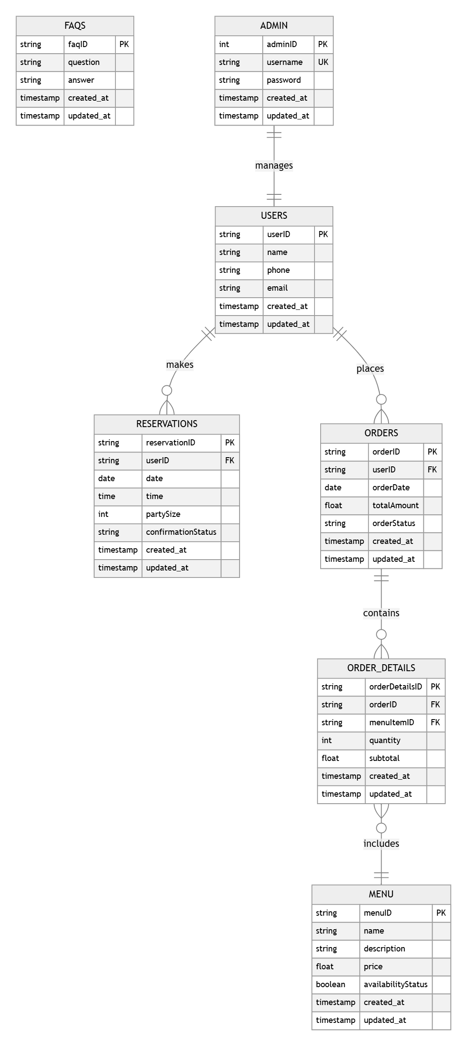

1. Sequence Diagrams (To be developed using Rational Rose or any other drawing software of your choice)

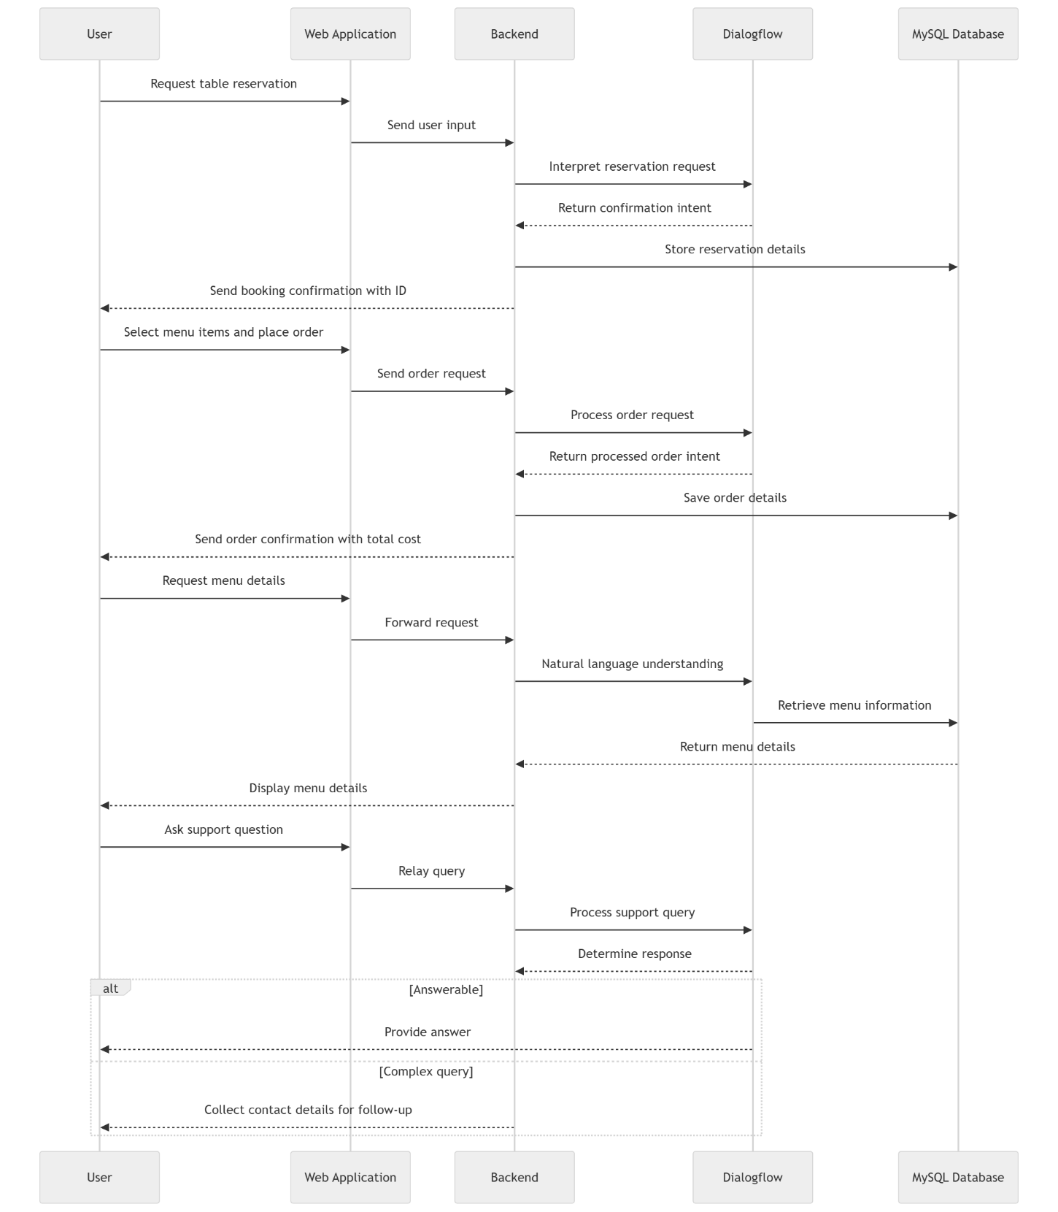

1. Architecture Design Diagram

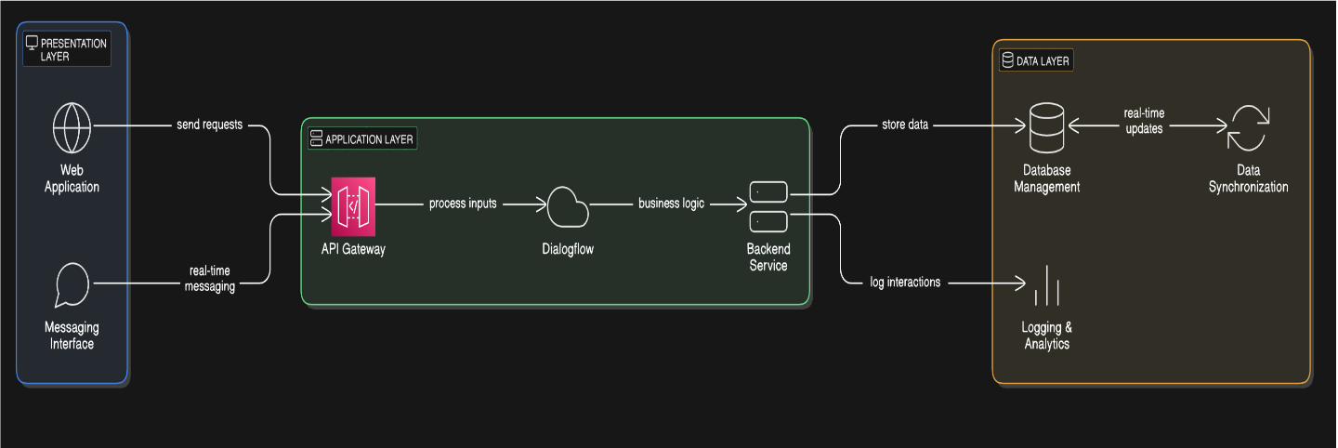

1. Class Diagram

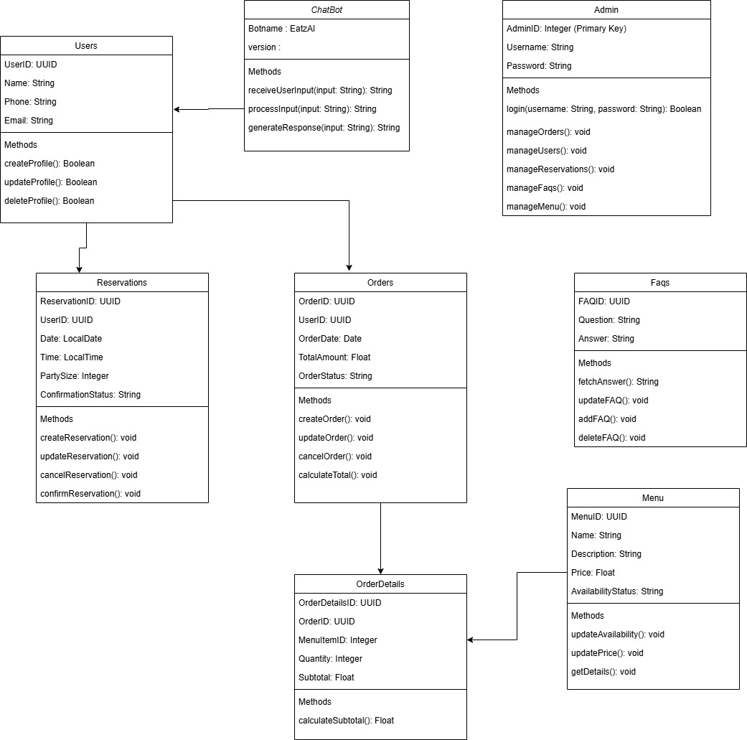

1. Database Design

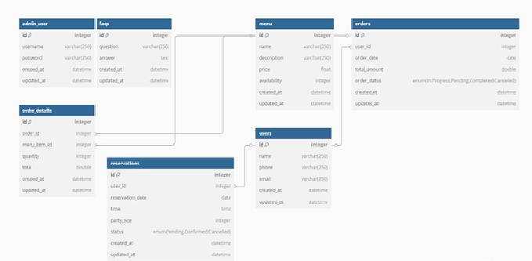

1. Interface Design

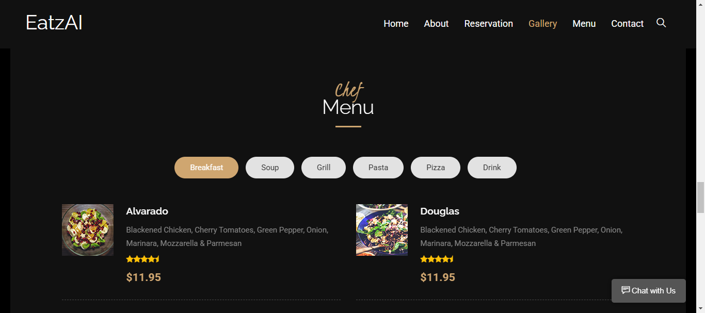

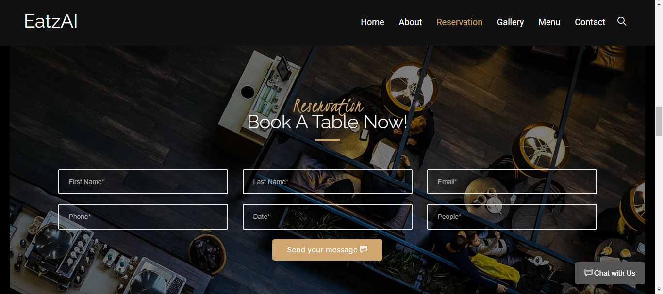

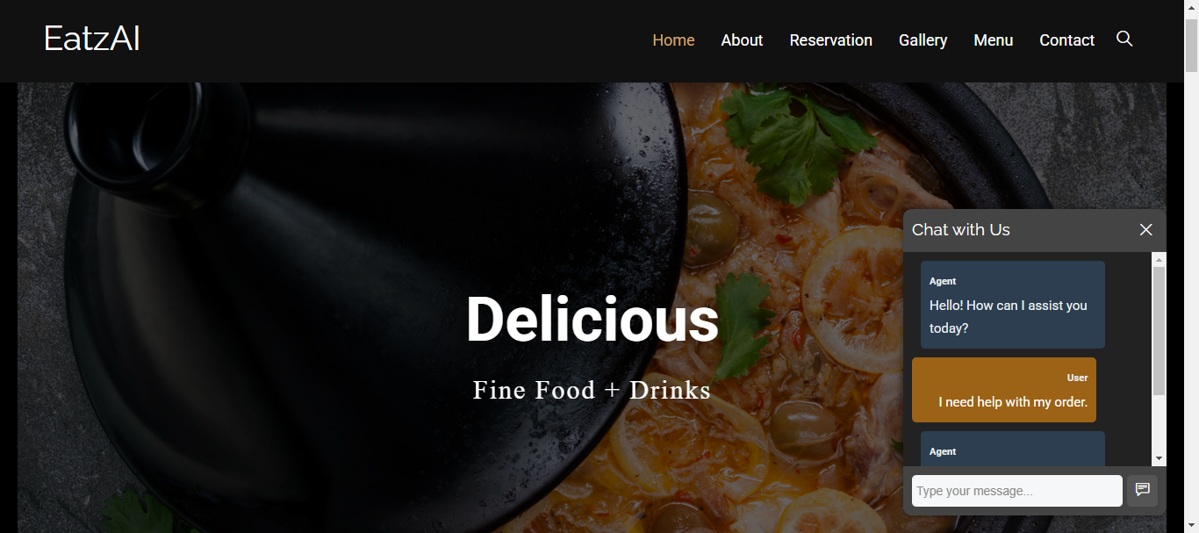

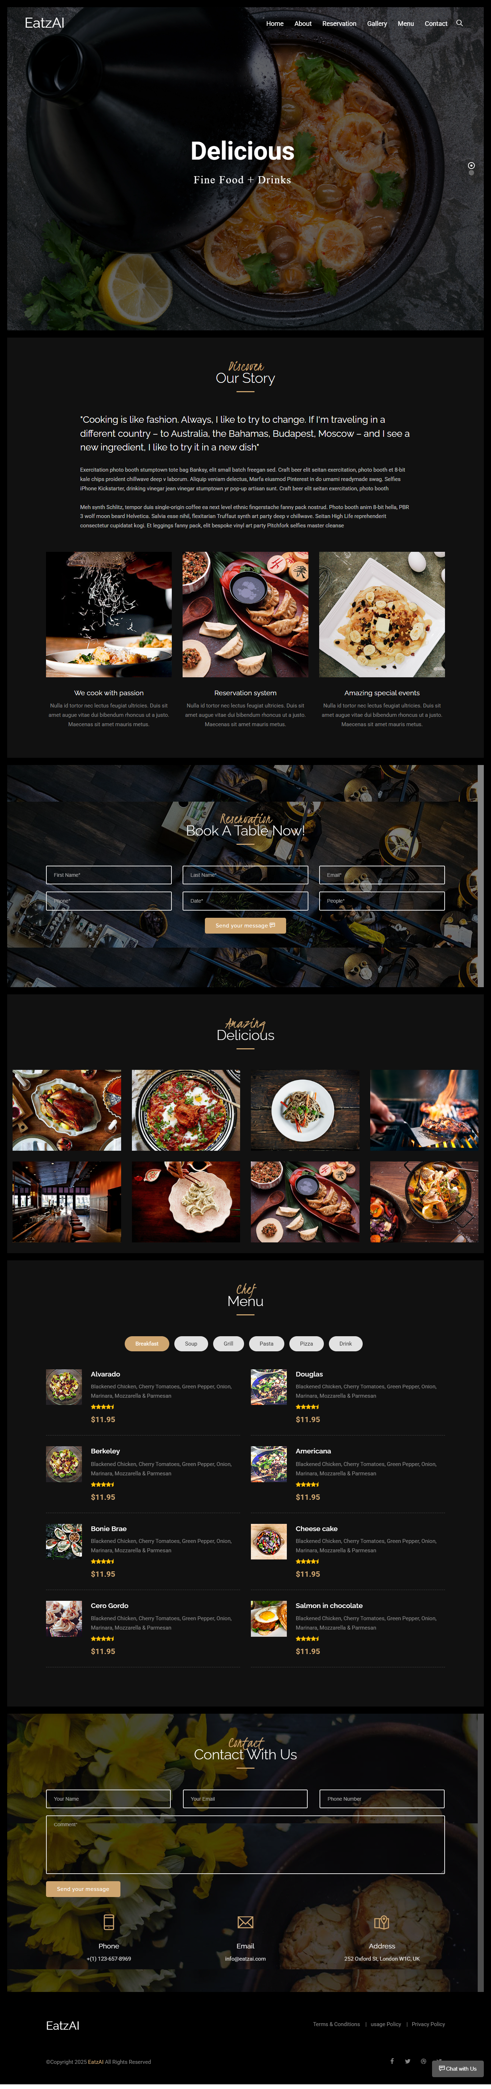

1. Test Cases

